Aakifah Muheb
Prof. George
Agentic AI
3/26/26

Milestone 2
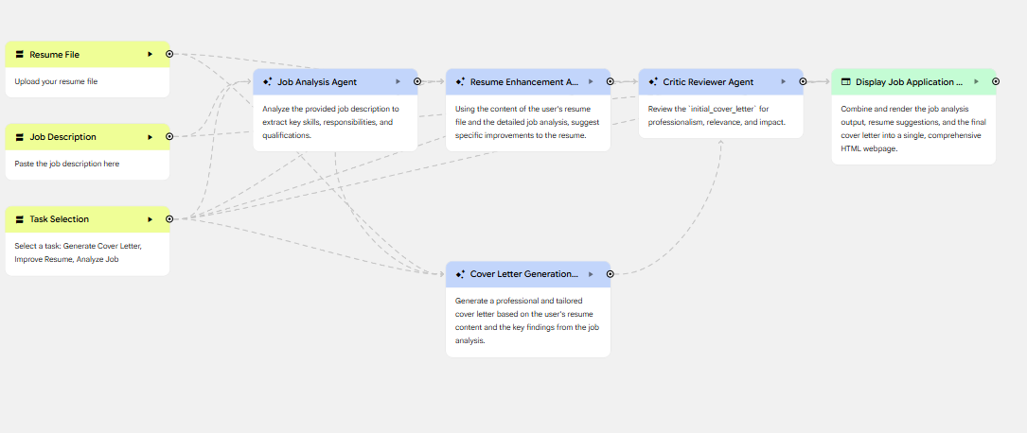

I worked on an internship and job application AI powered system that would help students and recent graduates with the internship and job application process. The application process can be very time consuming because applicants must tailor resumes, write personalized cover letters, and track application deadlines. This system is designed to simplify that process by using multiple AI agents that work together to complete all these tasks.
In this milestone the system includes a structured pipeline where different agents perform specific roles and pass information between each other.
The agents roles are:
Job Analysis Agent; this agent is the first processing step in the system and its role is to analyze the job description provided by the user and to identify the necessary skills and qualifications needed for that job. Inputs are job description and an optional resume file. Outputs are the skills required and responsibilities and qualifications associated with that job
Resume Enhancement Agent: This agent uses the user's resume and the output from the job analysis agent to suggest improvements. Inputs are resume file and job analysis output. Outputs are suggestions to improve resume and recommendations to better match job requirements. This agent makes sure that the resume aligns with the job description and it focuses on fixing the resume to make it more competitive.
Cover Letter Generation Agent: This agent is responsible for creating personalized cover letters for jobs. Inputs are resume file and job analysis output. Outputs are a tailored cover letter to that job. Creating a cover letter for every job application can be very time consuming so this agent is very helpful.
Critic Reviewer Agent: This agent reviews the generated cover letter and suggests improvements. Inputs are the cover letter generated by the previous agent. Outputs are feedback on clarity and professionalism and if needed, a revised cover letter.

The agents in this system communicate through a sequential pipeline, where each agent receives input from previous steps. This makes sure that all the outputs are connected. There are many challenges when working with AI generated outputs. The system may produce low-quality or inaccurate responses if the inputs are incomplete or unclear. To address this I added the Critic Reviewer Agent which acts as a quality control step that can review the generated cover letters and suggest improvements. This helps reduce errors and improves the overall quality of the system's outputs.

